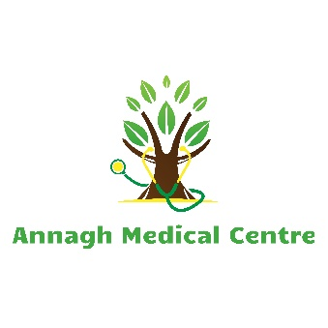
Annagh Medical Centre Repeat Prescription Form
Annagh Medical Centre, Doctor’s Road, Ballyhaunis, Co. Mayo. F35 X932. Tel: 094 9632232 Fax: 094 9632355 www.annaghmedicalcentre.com
PLEASE POST OR HAND INTO SURGERY PRESCRIPTION BOX OR RECEPTION
WE NO LONGER ACCEPT PHONECALL REQUESTS.
We only accept requests using this form or online via our website www.annaghmedicalcentre.com

For your safety and correct prescribing :
All medications should be requested at the same time.
We aim to complete request within 48 hours, but would appreciate 5 working days notice
If you have any difficulty completing this form please ask your pharmacist or family member for assistance
All prescriptions will be for three to six months at a time unless restrictions or safety issues apply.
DATE | SURNAME | FIRST NAME | Date Of Birth | CHEMIST
 |  |  | / /

No | Medication– Please write name of medication you require below
1
2
3
4
5
6
7
8
9
10
11
12
13
14
15

I confirm that I request all of the above medications be re-prescribed for my personal use.

Patient’s Signature: _________________________________ Date: ___ / ___ / ___

